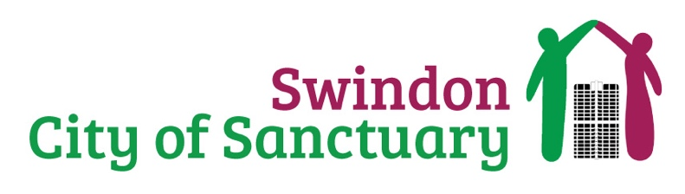
Website Maintenance
Charity Admin Support

Can you support our charity by keeping our website updated and functioning? We are looking for a tech savvy individual who is confident in website design and management. Our website is the first place prospective doners, volunteers and the public make contact with our charity, it is a vital tool that allows us to have the biggest impact in Swindon. We are looking for somebody to help keep it running smoothly.

ARE YOU skilled at website management and have a passion for supporting the community through offering your skills in website management? WE NEED YOU!

ARE YOU looking to gain experience at managing a professional website? WE NEED YOU!

ARE YOU able to Fix bugs, update content and navigate website management software? WE NEED YOU!

What will a website maintenance volunteer do?

- Manage the charities website.
- Fix bugs
- Help to upload content
- Regularly check that the website is functioning correctly.
- Take time once a week to check on the website and to make changes if necessary. The charity will work to fit this time around your other commitments.
- Have knowledge of website programming.
- Abide to the charities media and data protection policies.

The benefits to you?

- Opportunities to meet new people in your community
- The satisfaction of knowing you will be making a difference to the lives of people seeking sanctuary as part of the Swindon community.
- Reimbursement of volunteer expenses.
- Experience of managing a professional website.

Volunteers will work alongside staff and trustees from Swindon City of Sanctuary. Guidance and support will be offered to all volunteers who take on our website maintenance opportunity.

->Website
-> Get Involved
-> Volunteer

