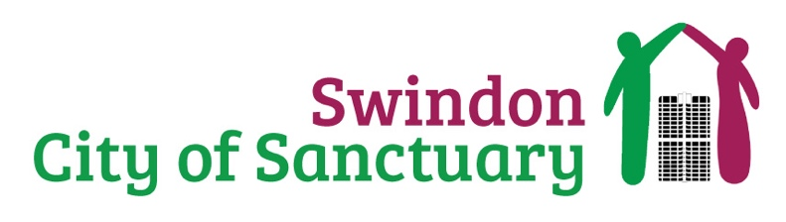
Translators
Charity Support

We have opportunities for people with good English skills who can speak other languages. Translators help the charity to overcome language barriers and offer the greatest assistance to the people we support. We welcome people who can translate all languages especially those of Arabic, Farsi and Ukrainian.

ARE YOU interested in supporting a charity that brings the community together through creating a culture of welcome and inclusion for all? WE NEED YOU!

ARE YOU wanting to support sanctuary seekers to communicate their needs or to just be a person to listen and support those experiencing the challenges of the asylum system? WE NEED YOU!

What will a volunteer translator do?

- Help to translate information for people who interact with Swindon City of Sanctuary.
- Improve understanding of support that is available to sanctuary seekers
- Translate charity policies and agreements.
- To support the charity in making all its content accessible to non-English speakers.
- To provide translation assistance where needed

The benefits to you?

- Opportunities to meet new people in your community
- The satisfaction of knowing you will be making a difference to the lives of people seeking sanctuary as part of the Swindon community.
- Reimbursement of volunteer expenses.

Volunteers will work alongside staff and trustees from Swindon City of Sanctuary. Guidance and support will be offered to all volunteers who take on our charity support roles.

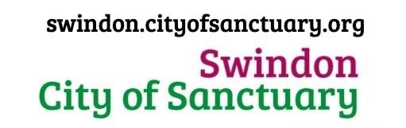
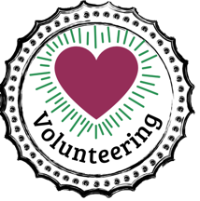
->Website
-> Get Involved
-> Volunteer

