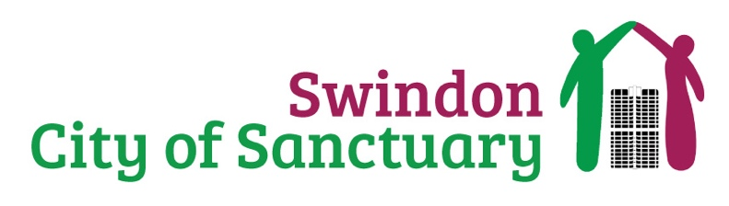
Social Media
Charity Admin Support

Can you support our charity by managing our social media platforms? We are looking for a tech savvy individual who knows how to get the best out of social media. Can you make media content accessible, meaningful, and impactful? Can you promote content that creates online community engagement?

ARE YOU a WIZZ at social media and have the skills to generate the greatest awareness of content? WE NEED YOU!

ARE YOU looking to gain experience at managing a charities social media feed while actively making a positive difference to the life of others? WE NEED YOU!

ARE YOU able to create a buzz online with content that celebrates, informs, and welcomes diversity and inclusion? WE NEED YOU!

What will a social media volunteer do?

- Manage the charities social media output.
- Know how to generate engagement with the local community and nationally, online.
- Self-motivated to gain as many views, likes, retweets as possible.
- Aim to make content go viral.
- Be available for 2 hours. The charity will work to fit this time around your other commitments.
- Know how to operate on different social media platforms.
- Abide to the charities social media and data protection policies.

The benefits to you?

- Opportunities to meet new people in your community
- The satisfaction of knowing you will be making a difference to the lives of people seeking sanctuary as part of the Swindon community.
- Reimbursement of volunteer expenses.
- Experience of managing social media on a professional capacity.

Volunteers will work alongside staff and trustees from Swindon City of Sanctuary. Training and guidance will be offered to all volunteers who take on our social media opportunity.

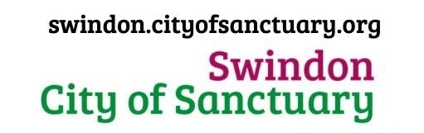
->Website
-> Get Involved
-> Volunteer

