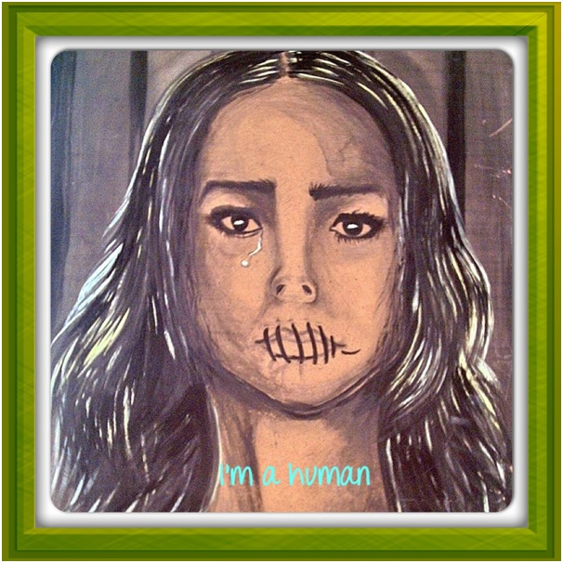

I’m human by Malka Al-Haddad

I’m from a country at war
I am from a country that’s bleeding
A country of anger
And revolutions
A country of martyrs,
I’m from a country once called Mesopotamia
I’m from the land of black gold
I’m from the richest land on the earth
I’m from the land of sunshine on a golden desert

I’m from there
But I’m not there

I had beautiful dreams
I had friends, brothers, sisters, sweet parents and pink hopes…
I had green gardens, tall palms and olive trees
I had a warm winter
Blue rivers
Red flowers
I was born on land before the crossing of swords on the body
Turned into a banquet table

Before Bush and Blair turned our rivers into blood
Then they donate us millions of tents instead of roofs for our houses
The rain has died in my homeland
They left graves in the green grass in our fields
Only cacti remain laughing in the barren desert
The sun has become ashamed behind the clouds
Where is God?
Has even God became a refugee in His land?!
Where is our ancient law?!
Even this been stolen?!

No choice
I crossed the seas of death
Waves of grief have led me here
To the land of my usurpers in an old and narrow shelter
No job
no identification
no dignity.
The victim cannot judge its executioner
I now speak in two languages, but I have forgotten in which one I used to dream
I have learned all the words to take
the lexicon apart for one noun’s sake,
The compound I must make:
Homeland

No choice I came here
I’m here
but I’m not here

You are a refugee and
Your choice is not your choice
But remember…
I’m human
I’m human

Malka Al-Haddad – Human Rights activist, poet, writer and artist.

