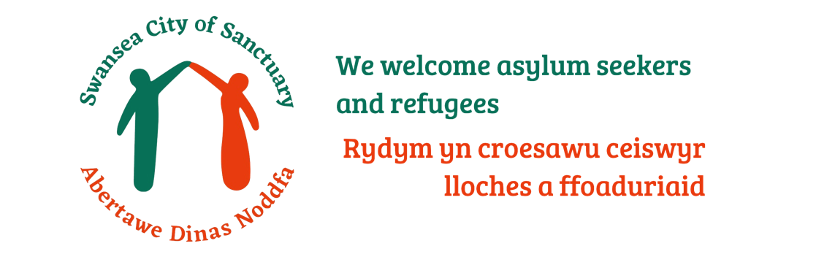
Swansea City of Sanctuary Award 2022
Application Form

Organisations are asked to submit a written application providing evidence demonstrating that the organisation addresses the three core values: Learn, Embed, Share.

The Swansea City of Sanctuary Awards 2022 will be presented in early November 2022 at our Annual General Meeting.

The nomination will be judged by a small panel. The judging panel may request a visit to the nominated organisation during the appraisal.

Please note that Swansea City of Sanctuary may use any information you supply for publicity / presentations. If you include quotes / photographs, please confirm that this is acceptable to persons concerned.

When completing the application form please note the following:

- Please demonstrate how your organisation has addressed the three core values beyond its normal day to day operations.

- Evidence can be collected through self-evaluation and through consultations with sanctuary seekers.

- Applications should be no longer than 4 pages. Only photos and other relevant documents can be submitted in addition to these 4 pages. Cap on additional pages = 4.

Completed application forms should be received Swansea City of Sanctuary before 5pm on Friday 30th September 2022 at the latest, by email to: swansea@cityofsanctuary.org

Please complete the table below and delete options where appropriate

Organisation Name:
Name of Contact Person:
Email Address:
Telephone Number:
Is your organisation a pledged supporter of Swansea City of Sanctuary? | Pledged Supporter  Member  Neither
Date application submitted:
If you have quoted named individuals, please confirm that you have their permission to do so: | Yes  No  N/A
If you have attached photos, please confirm you have obtained permission from those photographed to share these: | Yes  No  N/A
Please provide numbered list of any accompanying photos/docs cross referenced to the photos/docs:

Photographs/other documents (please list):

Signature to confirm permission for sharing photographs and any quotes from any named individuals has been obtained:

Name:
Signature:
Position in organisation:
Date:

- LEARN

Please explain and give examples of how your organisation has learnt about what it means to be seeking Sanctuary. (e.g. hosting an awareness raising session, attending a Swansea City of Sanctuary event, staff training sessions, attending conferences etc):

500 words

2 EMBED

Since learning about what it means to seek Sanctuary, what positive action has your organisation undertaken to make welcome and inclusion for those seeking Sanctuary a key part of your activities. (e.g. hosting events, involving those seeking sanctuary in your activities, altering your constitution to be more inclusive, contributing to the City of Sanctuary movement):

500 words

3 SHARE

How have you let others know about what you are doing and about the positive contribution refugees make to our society? Please explain how you have you shared the Swansea City of Sanctuary vision with others (e.g. media articles, social media, events):

500 words

Thank you for taking the time to complete the application form. Please send to swansea@cityofsanctuary.org before 5pm on Friday 30th September 2022.

We look forward to reading about the work you have been doing!

