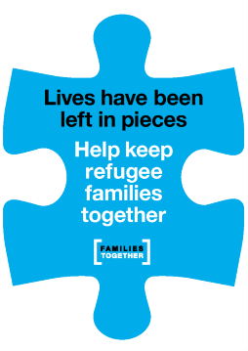
The Families Together Digital Organising Fellowship Form

Hello!
Thanks so much for your interest in joining the Families Together Digital Organising Fellowship – it’s great to have you on board!
Complete the form below to express your interest and we will share information about the sessions and how to sign up. You will then need to email your completed form to Sophie at smorbey1@oxfam.org.uk. If you have any questions at all, please do get in touch!
………………………………………………………………………………………………………………………………………………………………………
Full name:
Are you a campaigner with an organisation – if so, which one, and in what capacity?
Please indicate which training dates can you make below (please note you will need to be able to make at least 2 sessions):
2nd February, 6.00pm – 7.30pm:
23rd February, 6.00pm – 7.30pm:
16th March, 6.00pm – 7.30pm:
6th April, 6.00pm – 7.30pm:
Please share briefly why you want to be part of the fellowship:
Do you have any access requirements?

