Minutes from City of Sanctuary AGM
Newcastle Civic Centre 15th of May 2018

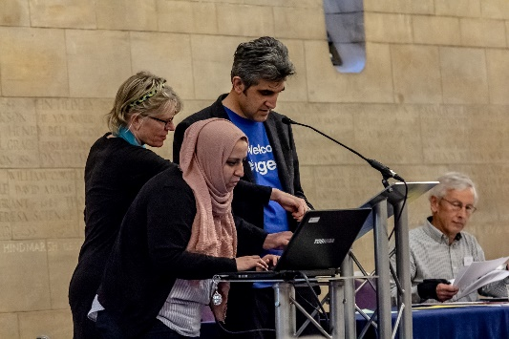
Apologies: from retiring trustees Alan Thomas and Rodrigo Edema and many groups who were unable to attend
- Minutes from last year’s AGM approved
- Sabir gave the Chair’s report. Very exciting year and great to have the increased capacity of the regional coordinators.
- Treasurer’s report: Andrew White gave a report on the finances for the last 12 months. The full report will be on the website in the next few days. Andrew gave some highlights:

- It is the first year that Asylum Matters was included which has doubled the size of City of Sanctuary in terms of money and staff size
- Staff numbers have grown from 5.5 to 10.5 – and in 2018 by another three. This is the equivalent of growing from 4 full time staff to 8.
- Guardian grants successfully given to local groups.
- We have been able to increase the level of our free reserves. Reserves now above the minimum level set by the trustees of £60,000.
Andrew thanked the charitable trusts who support the movement including Joseph Rowntree, Network for Social Change, STAR, Paul Hamlyn, Esmee Fairbairn, Barrow Cadbury, Unbound Philanthropy and LUSH.

- Amendments to the constitution.
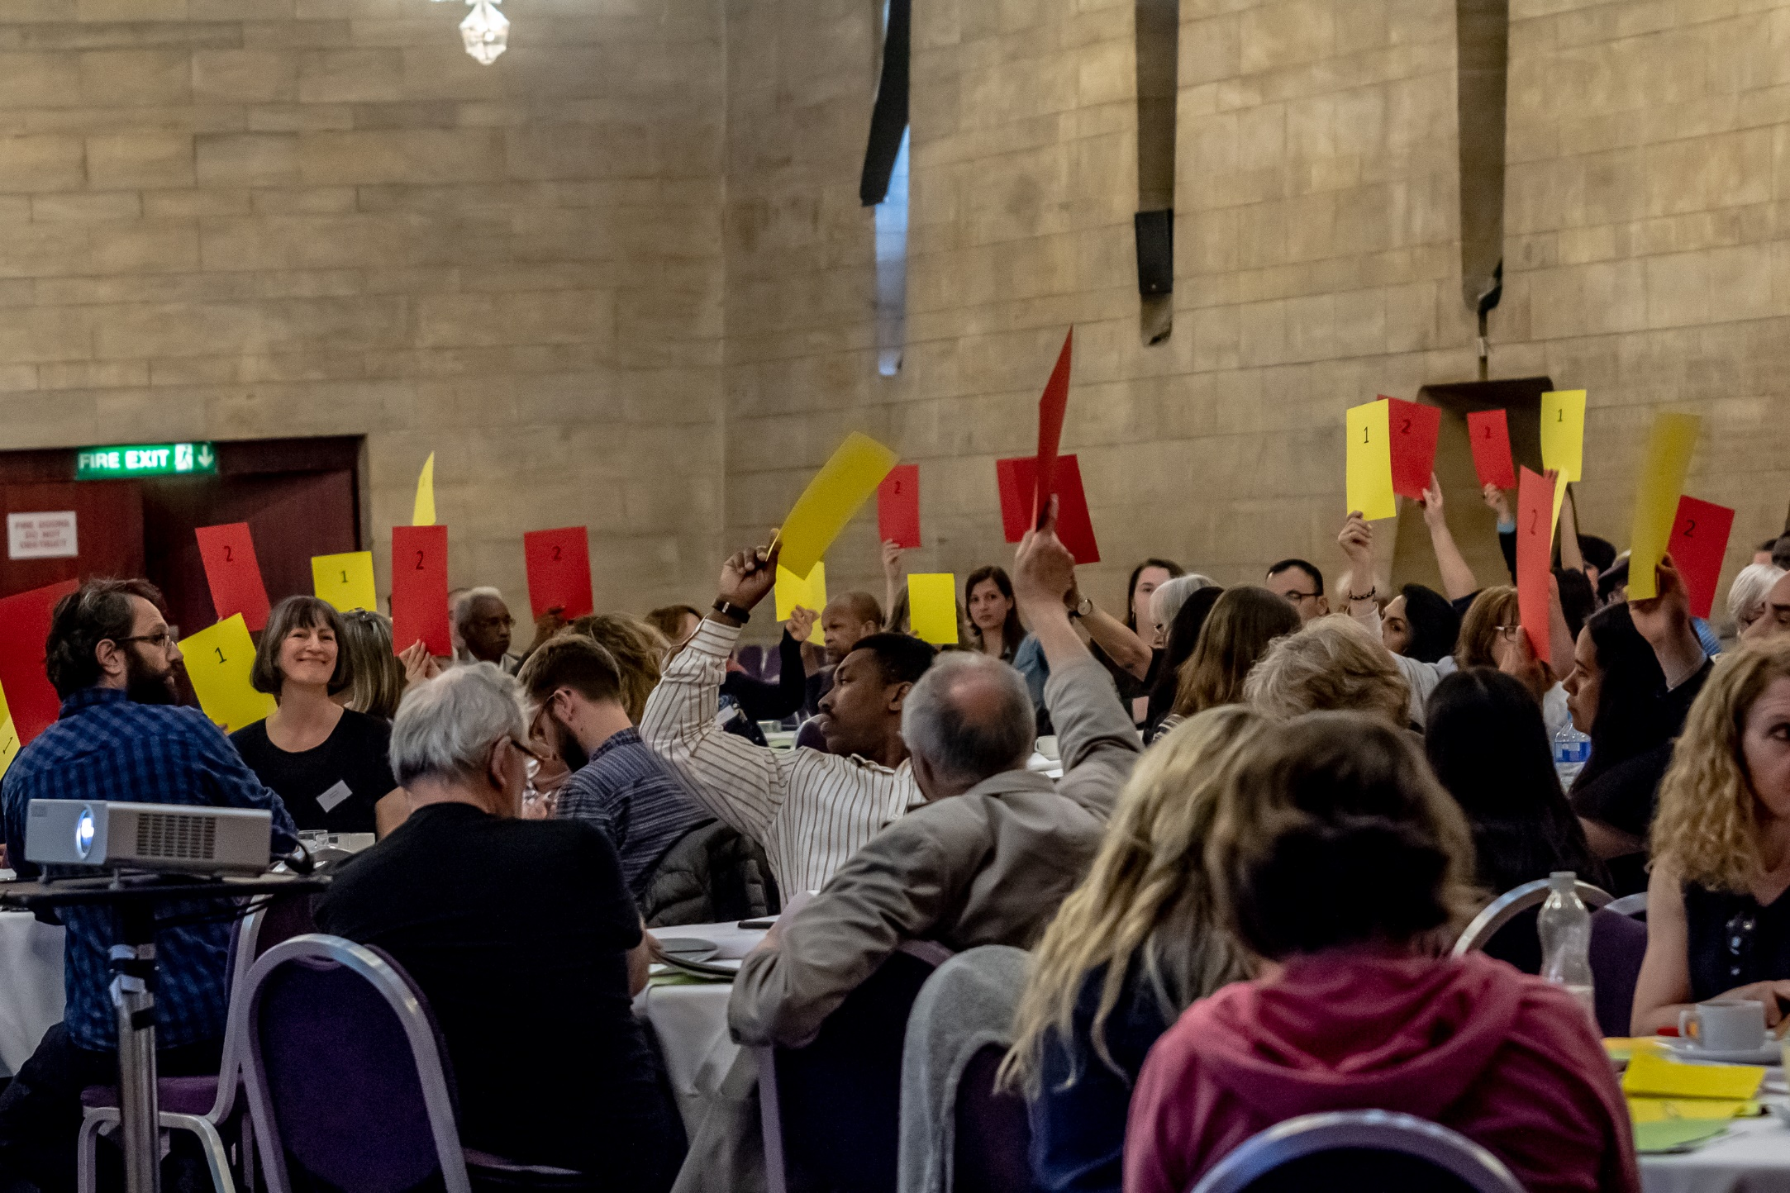
Jeni Vine (Secretary) summarised the two amendments being proposed.
Amendment 1: Simplifying the membership process so any individual can apply to become a member
In favour – 61. Against – 0. Abstain – 0.
Amendment 2: Reducing the maximum number of trustees on the board to 12. This will involve setting up a network advisory board to inform the trustees
In favour - 61. Against - 0. Abstain – 0.
Groups voting

Ripon
Cardiff
Swansea
Bradford
Northumberland
Swindon
Hastings
Tees Valley
Durham
East Kent
Loughborough
Southampton
Cambridge
Bolton
Sheffield
Norwich
Leeds
Exeter
Belfast

- Elections of trustees
No further nominations came forward.
Sabir thanked the trustees who are standing down: Alan Thomas, Betty Nyamwenge, John Mellor, Marzia Babakarkhail, Rodrigo Edema, Roger Nyantou. Some of them are joining the advisory group.
Sabir introduced the remaining board members: Andrew White, Caroline Beatty, Herbert Dirahu, Jeff Morgan, Jeni Vine, Jonathan Ellis, Pam Inder and himself, Sabir Zazai.
The board has recently carried out a skills audit and will be looking for people with the required skills to co-opt to the board over the year ahead.
Following feedback from the tables at the conference, a date will soon be set for the first Network Advisory Board meeting.

