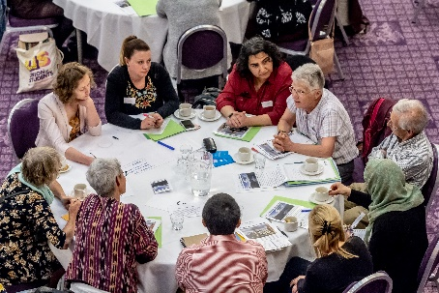
National Conference 2018 Roundtable

Discussion led by Jonathan Ellis:
- What activities, projects and initiatives (including streams) does your group take part in or aspire to?
- How do they help to realise the City of Sanctuary vision?
- How can the new National Advisory Board keep us all connected and stay true to our principles and vision?

Collated Notes from 15 different discussion groups
(Not all groups named in the notes)

- What activities, projects and initiatives (including streams) does your group take part in or aspire to?

- Manchester – growing charity
- Conversation club
- Befrienders /mutual welcome
- Each month led by a different country food / culture
- Printed guide
- Re-directing. Signposting
- Fun +friendship
- Pledges
- Wellbeing programmes
- WEERS- Education programme
- schools
- universities
- church groups
- 2500 people /year
- 7 min film about asylum process

- Solace
- training for health professionals
- Mental health pack – trying to get out to GPs
- Newcastle
- Advocacy services on health and social care
- Work with BME
- RAS group
- Advocacy for hate crime victims
- Freedom from torture
- Newcastle -CCG dashboard
- (partner) not enough support from CoS or refugees agencies
- Partnering services with some of the agencies
- voluntary group, supporting Syrian – learn more
- Crossings community group – Weekly safe space, music sharing +learning sessions in Newcastle
- Bristol:
- DND
- Transport fund
- University of Bristol and working with VWE
- School of Santuary
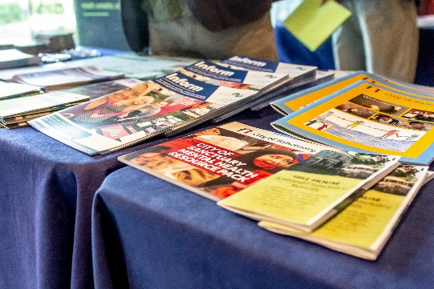
- Quaker
- NACCOM support
- Scaling advice within the system to fund work /still placement
- Media outreach
- Aid box community
- Funding the other agency
- Migrant launcher, migrant organised
- Bradford:
- 850 asylum seeker
- 176 agencies have signed up pledges with Bradford CoS
- 16 + 2 sanctuary scholarship
- School programme
- Finding work possibilities for refugees
- Media outreach (Huffinton)
- Newsletter- work with migrant launcher & very helpful volunteer
- Durham:
- Resettlement program for Iraq, Syria
- They want to be partners with CoS
- Free minibus for the student union
- GCSE, ESOL support from the university
- Voluntary recruitment for befriender/ trainer

- Women’s network. Small community group – address social a +cultural tolerance isolation of women. Activities for woman. Anti-racism counter demonstration
- Loughborough – welcomes Asylum seekers who are told to report at Loughborough Centre. Breaking down hostility amongst people such as security staff, passers-by. Volunteers
- Kent schools of sanctuary – delivers workshop on migration, asylum seekers, refugees in schools. Setting up of Schools of Sanctuary-through arts- multicultural festival – positive press – Dover.
- Southampton School of Sanctuary – 10 schools of sanctuary,
- University of Winchester set to become a university of Sanctuary.
- Sanctuary in Politics Dublin- interactive teaching session about politics +politicians surrounding asylum and migration with politicians, media
- Asylum Guides Project groups
- RA- all v support infrastructure
- Delivered by groups
- Guides – individuals / groups
- Useful Website
- Growth of groups
- Support Asylum Seekers + Refugees
- At our drop – in
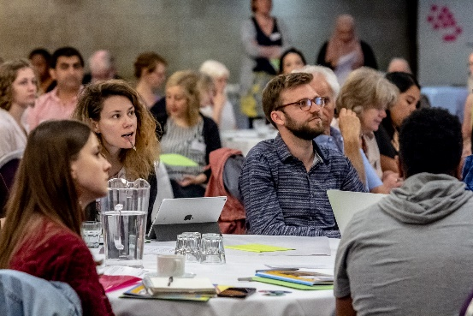
  - Casework
  - Hot Meal
  - Week of groceries
  - ESOL Classes
  - Free clothes
  - Football
  - Translation services
  - Tea, coffee, fruits
  - Social setting
  - Safe
  - Pool tables +table tennis
  - Football tables?
  - 150 + attendees at each drop in – all free – all volunteers
- The Women’s Drama group
- Destitution Project –Bolton: help people support them, Refugee and asylum seeker befriend, sometimes we help with advice, clothes, food, free many things
- Dinner Parities: Inviting Refugees & Asylum seekers to the theatre along with other members of local communities to host them for a thre course dinner.
Everyone encouraged to tell their stories about coming to Bolton. From those dinners people were invited to join an Ideas group to become stakeholders in the theatre by suggesting projects, plays and events that the theatre can undertake. Sharing food, sharing stories, sharing community.

- Octagon theatre- participants join after attending dinner to talk about the programme and projects of groups the theatre runs. The group is now curated by participant stakeholders
- Sanctuary suppers
- Maternity
- #refugees welcome in parks inclusion and wellbeing. Parks & green spaces together with refugee support organisation to enjoy being outside. Claire Landscape architecture Sheffield University
- Parks
- Free
- Join in
- Feel better
- University – Dublin City Uni – Uni of sanctuary
- Scholarships
- Story telling project (community activity) – English language
- Yorkshire +Humberside
- Training awareness for midwives
- Mental health pack – training for direct health provision
- Sport for integration
- Faith based forum – Derby- Cathedral of Sanctuary
- Sheffield – The Sanctuary – welcome Hub- tea, music, choir, ESOL, Sing, posting- ITV Peoples project/TSB grant
- Hate crime reporting
- Belfast City of Sanctuary
- Ulster University scholarships for sanctuary seekers
- Tickets -D access library services + computer
- Campaigns (families together, scholarships)
- Education events (lectures, panels)
- Workshops, training , youth club, conversation groups, drop in, school projects, involve asylum seekers/ refugees
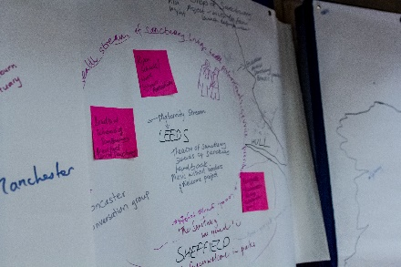
- Activities:
Sessions, cultural activities, food festivals, driving theory classes, skills-orientated sessions, translation services + support (GP appointment), exercise classes, arts- based projects, music, provide furniture +objects for homes + television licenses, celebration events, women’s group, ESOL classes, partnership (churches, red cross, council support) local network of support, student volunteers
- Weekly programme + provision of services:
- Need more : English language support, legal access, volunteer support, increase funds, support network, sanctuary awards, paid staff member

- East Kent Network of Sanctuary
- opportunities to work
- invite in service provider
- raise awareness + advertise what the needs
- Sanctuary in parliament
- destitution
- mental health
- School of Sanctuary
- + ARE
- Health implications
- Tees Valley – GP’s +working with partners +having a focal point Justice first +Pete led initially + then finding hosts – coordination role/ interagency
- Bristol Network have acquired a house – transition for refugees
- Dublin University-provides scholarships

- How do they help to realise the City of Sanctuary vision?

- Questions around structures – how do we attract leaders & ensure that refugees are involved in leadership positions
- Purpose of Charter/principles to make sure no matter how they grow, they follow principles
- A sense of inclusion and belonging
- Listening to what people have to say and a voice to link issues that people share

- Opportunities for partnership / collaboration with Refugee Action
- Opens up new networks
- Local and regional important
- An umbrella over the umbrellas
- Welcoming everyone, including everyone
- Creating a platform for asylum seekers & refugees
- Merging with other agencies to create more welcoming place
- Partnering with other agencies no related to A&R & …..
- Strong themes of work in schools- promote understanding +raise awareness

- People doing ‘informal advocacy’
- Befriending
- Telling people about refugee issues
- Universities of Sanctuary-
- Minimum baseline of criteria
- All agree share is the hardest thing to prove – uni must advertise their status /vice chancellor must give a signed declaration. Informal integration of refugee students – eg theatre groups etc – City of Sanctuary union societies/STAR -embed
- People can still be involved if funding is revoked.
- Extra English exams/support to help, transfers + get levels – volunteers, difficult to evidence qualifications
- Transfer qualifications –‘recognise prior Learning’

- How can the new National Advisory Board keep us all connected and stay true to our principles and vision?
- National Advisory group – arts group meet once or twice a year.
- Assessing impact
- Collective leadership
- Advisory board
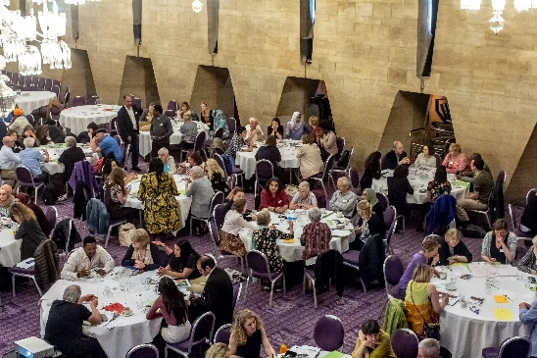
- Central information
- Seek advice
- Making connections
- Have more impact – can be creative
- Needs to have asylum seeker representation
- Advocacy / outreach to different sectors
- Peer evaluation
- Critical friend
- Ultra-specialist (maybe?)
- Maintaining the connection
- Newsletter & social media
- Regional coordinating meeting more regularly
- Planning advance meetings for national meeting/ sanctuary in Parliamentcan we do anything to help any destitute or other victims of the system?
- Finding a way to set funding for the group
- Campaign for A&R
- Connection to global connection
- More connection with Asylum Matters
- What is the objective of the Advisors Board – what does it do that is not already being done (eg streams)

- Looking beyond the national team for impact
- Making connections between streams
- Regional representation
- How will it be managed?
- Maybe it should be called a ‘group’ rather than a ‘board’ –(not involved with governance
- Remember we are a national movement - regional coordinators
- Collective leadership?

- Working groups for streams (same autonomy) but a link with advisory board – staff leads involved in working groups (who then link with trustees/ and consult advisory board when necessary
- Set numbers of refugees Champions.
- Regional leads / sector leads:
- Health
- Education (uni+ schools)
- Awareness raising and sanctuary breaks

- NAB – tackle an issue per meeting – people can come if they have something to contribute – different people coming each time
- Core /co-opted
- Have people not connected to CoS? With influence in the sector
- G4s/Serco could invite for specific themes
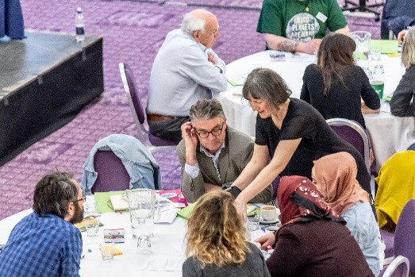
- Health
- Refugee council
- Home office?
- Legal
- Detention centre
- Red Cross
- Forum /for CoS groups -message boards– ask for advice/experience from groups

