Notes from City of Sanctuary Conference
Newcastle Civic Centre 15th of May 2018
Part 2 - afternoon session

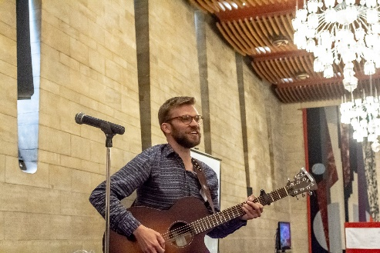

Sam Slatcher welcomed people back after lunch with his City of Sanctuary song

Sabir Zazai announced this year’s ‘Champions of Sanctuary’ who have gone the extra mile to promote the work of Sanctuary.

- John Mellor – for his long service to the trustee board, in particular for raising awareness of rural issues
- Pete Widlinski – for his long service to refugees and asylum seekers in the North-East
- Sarah Smart – for her long service to Newcastle City of Sanctuary
- Mina Nielson – for the technical development of the City of Sanctuary website since it began and for her many hours of voluntary work behind the scenes
- Roger Nyantou – for his long service to the trustee board and dedication to the cause of sanctuary. Roger comes from a refugee background and turned his own challenges into supporting the aspirations of others.

Sabir gave thanks to Susan for chairing the morning session and to Joseph Chivayo from Derby City of Sanctuary for chairing the afternoon.

Sabir recognised the Octagon Theatre by giving them a Theatre of Sanctuary award. Trustee Jeff Morgan shared some of the work that the Octagon Theatre has been doing. Joseph talked about the importance of awards in growing the Sanctuary movement.
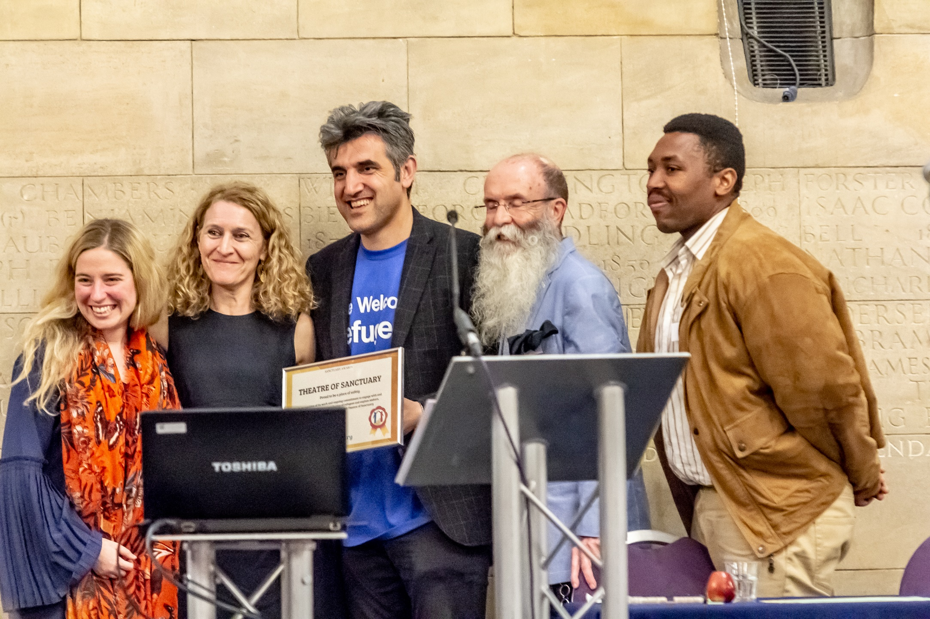

Asylum Matters: advocacy and campaigning on asylum and refugee matters – Joe Allen presented for the team

They are a small team distributed around the UK with four objectives:
- To build capacity for campaigning work
- To link local and national campaigns together
- To bridge gap between policy and practice
- To directly engage with the Home Office and make the case for reforms
Expecting the Government to publish its paper on the post-Brexit immigration system before the summer recess.

3 priority areas in the coming months:
- Asylum support rates
  - Looking to secure a parliamentary debate
  - Will then run a national campaign for support
- Integration

  - Government has published its integration strategy for England
  - Consultation on the paper is currently open
  - Asylum Matters has created a template response to help groups respond
- Permission to work
  - The UK has one of the most restrictive policies in Europe on allowing asylum seekers to work
  - Focus is on asylum seekers having a right to work and not an obligation to work
  - Decision not to directly target the Home Office on this but an opportunity to push Parliament for an amendment on the Immigration Bill coming soon

Jane Richardson – Schools of Sanctuary
When Jane retired she worked with the school where she had been teaching to help them work towards the School of Sanctuary award. ‘The award has changed the school.’
You start with a vision – ‘what would you like to see the school changing into?’ Carried out the audit – got all the staff, students and teachers involved.
Set up a group of staff across all subjects who met every 6 weeks with students. They produced assemblies, displays, talks to parent’s evenings, training with governors.
Everyone in year 7 and 8 had seven weeks’ work based on statistics on asylum seekers and refugees. As a result, pupils wrote letters to the Government and complained about the welcome our country is giving people compared to other countries.

Rebecca Scott – Wales Coordinator for City of Sanctuary
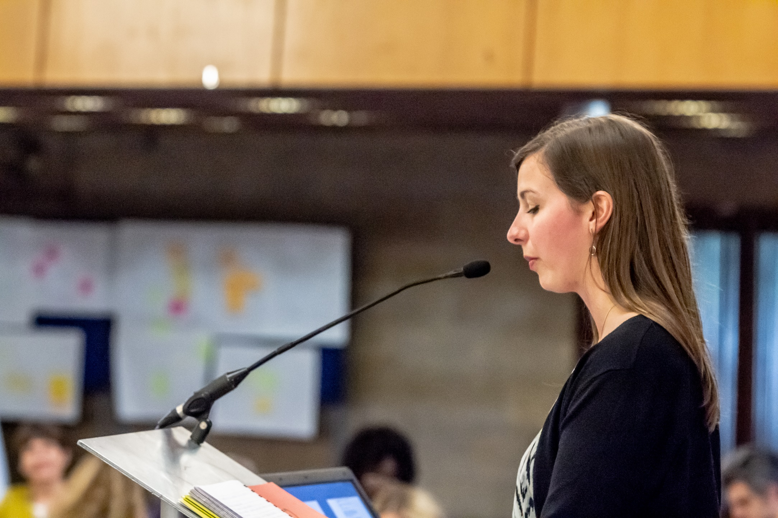
Still working towards the vision of Wales becoming a Nation of Sanctuary.
There is an increasing number of groups in Wales.
Continuing the sanctuary seekers speaking programme which supports sanctuary seekers to tell their stories.
First Museum of Sanctuary was awarded in Swansea recently.
The Welsh Government has started to put together a Nation of Sanctuary plan and consulted with over 100 sanctuary seekers to develop the plan. Aiming to be distinct to the hostile environment – it is open to consultation until late June.
Public Health Wales have commissioned research on barriers and enablers to sanctuary seekers accessing health care. They are interested in becoming an organisation of sanctuary.
TUC Cymru have signed up to the Nation of Sanctuary vision and support the idea of the right to work for asylum seekers.

Veronica Crosbie – Universities of Sanctuary
Dublin City University became the first University of Sanctuary. The focus was on getting all parts of the university involved including the President, the

Student Union and others. Four of the seven universities in Ireland are designated as Universities of Sanctuary. The other 3 are working towards the award.
Veronica spoke about the University of Sanctuary idea at a conference in Finland and there was a lot of interest from academics across Europe. The group in Ireland has run webinars to support more universities to be involved.
They are talking to the Department of Justice about how they can support them to improve integration issues.

Workshop notes in separate document

Vice-Chair Jonathan Ellis brought the conference to a close with a summary of the day and inspired everyone to continue their important work of welcome and noted the incredible difference they are all making.

