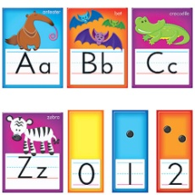**‘Family Learning in ESOL’ Workshop – Mary-Rose Puttick**

**Recommended websites for free resources:**

[**www.bbc.co.uk/bitesize**](http://www.bbc.co.uk/bitesize)

[**http://www.ruthmiskin.com/en/parents/**](http://www.ruthmiskin.com/en/parents/)

[**www.crickweb.co.uk**](http://www.crickweb.co.uk)

[**www.storymuseum.org.uk**](http://www.storymuseum.org.uk)

[**https://www.oxfordowl.co.uk/**](https://www.oxfordowl.co.uk/)

[**http://www.bedtimeshortstories.com/three-little-pigs-short-story**](http://www.bedtimeshortstories.com/three-little-pigs-short-story)

[**http://www.familylearning.org.uk/**](http://www.familylearning.org.uk/)

[**www.learnenglishkids.britishcouncil.org**](http://www.learnenglishkids.britishcouncil.org)

[**www.bigbrownbear.co.uk**](http://www.bigbrownbear.co.uk)

[**www.mad4maths.com**](http://www.mad4maths.com)

[**www.littlebridge.com**](http://www.littlebridge.com/) now available free of charge to all refugees and asylum-seekers. If you would like to take advantage of this offer, please contact Sarah White: [sarah.white@littlebridge.com](mailto:sarah.white@littlebridge.com)

MC900071179[1]